Microsoft Teams: PowerShell Support

How to download, install and run the a few examples in the Microsoft Teams PowerShell module. At the time of this writing, the following cmdlets are available:

* [Add-TeamUser](https://www.powershellgallery.com/items?q=Cmdlets%3A%22Add-TeamUser%22)
* [Get-Team](https://www.powershellgallery.com/items?q=Cmdlets%3A%22Get-Team%22)
* [Get-TeamChannel](https://www.powershellgallery.com/items?q=Cmdlets%3A%22Get-TeamChannel%22)
* [Get-TeamFunSettings](https://www.powershellgallery.com/items?q=Cmdlets%3A%22Get-TeamFunSettings%22)
* [Get-TeamGuestSettings](https://www.powershellgallery.com/items?q=Cmdlets%3A%22Get-TeamGuestSettings%22)
* [Get-TeamMemberSettings](https://www.powershellgallery.com/packages/MicrosoftTeams/0.9.0?q=Cmdlets%3A%22Get-TeamMemberSettings%22)
* [Get-TeamMessagingSettings](https://www.powershellgallery.com/items?q=Cmdlets%3A%22Get-TeamMessagingSettings%22)
* [Get-TeamHelp](https://www.powershellgallery.com/items?q=Cmdlets%3A%22Get-TeamHelp%22)
* [Get-TeamUser](https://www.powershellgallery.com/items?q=Cmdlets%3A%22Get-TeamUser%22)
* [New-TeamChannel](https://www.powershellgallery.com/items?q=Cmdlets%3A%22New-TeamChannel%22)
* [New-Team](https://www.powershellgallery.com/items?q=Cmdlets%3A%22New-Team%22)
* [Remove-Team](https://www.powershellgallery.com/items?q=Cmdlets%3A%22Remove-Team%22)
* [Remove-TeamChannel](https://www.powershellgallery.com/items?q=Cmdlets%3A%22Remove-TeamChannel%22)
* [Remove-TeamUser](https://www.powershellgallery.com/items?q=Cmdlets%3A%22Remove-TeamUser%22)
* [Set-TeamFunSettings](https://www.powershellgallery.com/items?q=Cmdlets%3A%22Set-TeamFunSettings%22)
* [Set-TeamGuestSettings](https://www.powershellgallery.com/items?q=Cmdlets%3A%22Set-TeamGuestSettings%22)
* [Set-TeamMemberSettings](https://www.powershellgallery.com/items?q=Cmdlets%3A%22Set-TeamMemberSettings%22)
* [Set-TeamMessagingSettings](https://www.powershellgallery.com/items?q=Cmdlets%3A%22Set-TeamMessagingSettings%22)
* [Set-Team](https://www.powershellgallery.com/items?q=Cmdlets%3A%22Set-Team%22)
* [Set-TeamChannel](https://www.powershellgallery.com/items?q=Cmdlets%3A%22Set-TeamChannel%22)
* [Set-TeamPicture](https://www.powershellgallery.com/items?q=Cmdlets%3A%22Set-TeamPicture%22)
* [Connect-MicrosoftTeams](https://www.powershellgallery.com/items?q=Cmdlets%3A%22Connect-MicrosoftTeams%22)
* [Disconnect-MicrosoftTeams](https://www.powershellgallery.com/items?q=Cmdlets%3A%22Disconnect-MicrosoftTeams%22)

Allow PowerShell to automatically download and install the module from the [PowerShell Gallery](https://www.powershellgallery.com/items). Let's step through that together:

First, launch PowerShell as an administrator by typing **PowerShell** in the start menu then right click *Windows PowerShell* and select **Run as administrator.** At the UAC prompt click **Yes**.

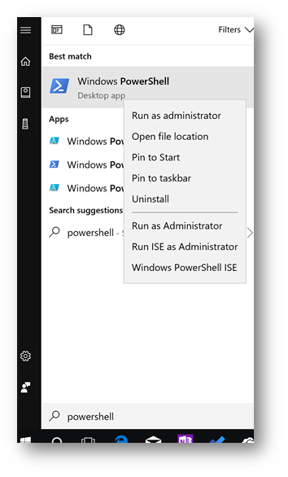

Prérequis :**Telecharger Installer Skype for Business Online, Windows PowerShell Module**

<https://www.microsoft.com/en-us/download/details.aspx?id=39366>

* Si vous executez un scrip powerShell pour la première fois, autorisez l’execution de script:

**Set-ExecutionPolicy Unrestricted**

* Importer le Module Skype Online Connector

Import-Module " C:\Program Files\Common Files\Skype for Business Online\Modules\SkypeOnlineConnector\SkypeOnlineConnector.psd1"

Next, within PowerShell type the following and press **Enter:**

|  |
| --- |
| Install-Module MicrosoftTeams |

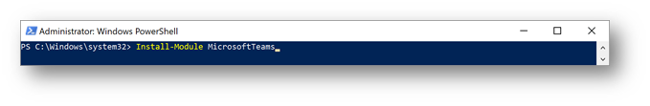

At the prompt type **Y** and press **Enter:**

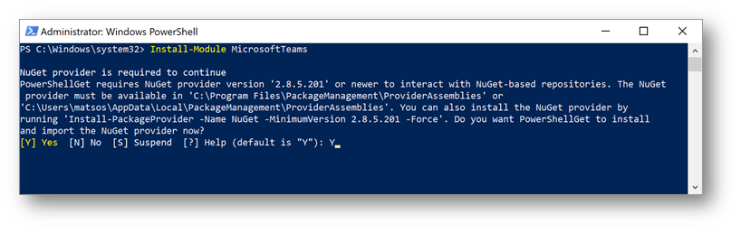

If you are prompted for untrusted repository, type **A** (for Yes to All) and press **Enter.** The module will install.

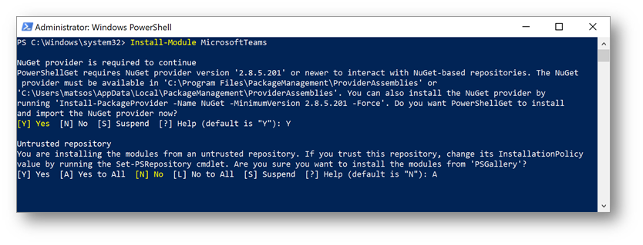

Once installed, we can now connect to Microsoft Teams. To connect type the following and press **Enter:**

|  |
| --- |
| Connect-MicrosoftTeams |

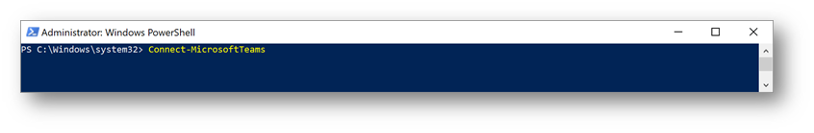

At the Microsoft Teams PowerShell Cmdlets dialog box, type your Office 365 credentials and press **Enter**

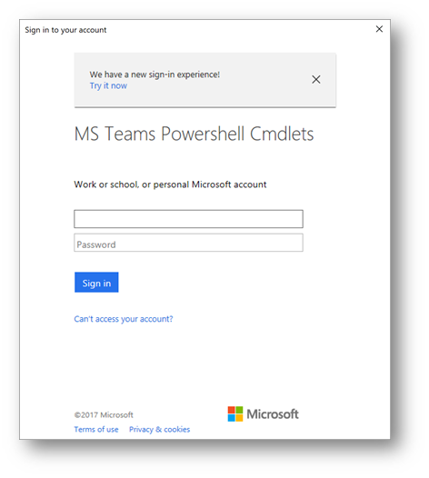

Once connected to the Microsoft Teams instance in your Office 365 tenant, the following will be displayed:

gra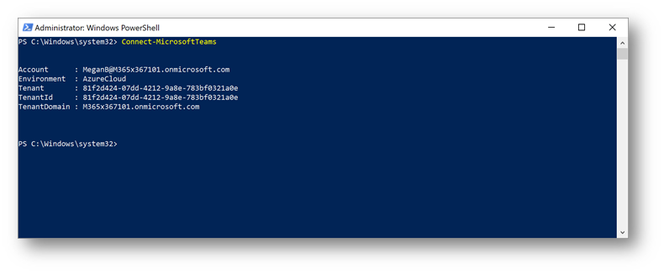

You can now start to run cmdlets, or scripts against Microsoft Teams! Note, at any time you can type Get-Command -Module MicrosoftTeams to see a full list of commands available:

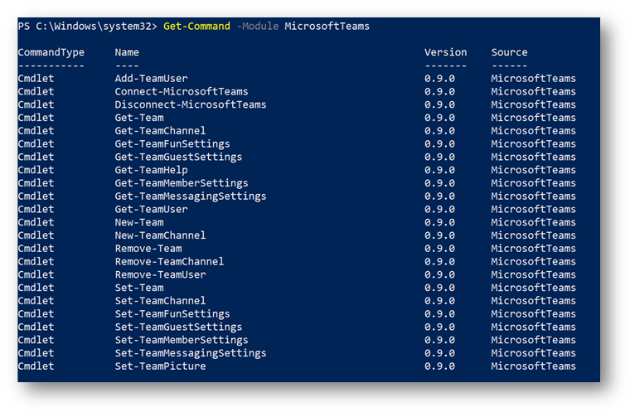

To return a list of the teams in the environment, type the following and press **Enter:**

|  |
| --- |
| Get-Team |

**Note:** Within PowerShell, teams are referenced as a *GroupID* for the underlying Office 365 Group.

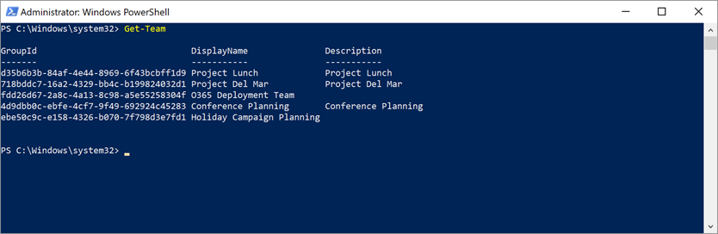

For the next example, let's create a new team for marketing employees in San Diego that is a private team. Type the following command and press **Enter:**

|  |
| --- |
| New-Team -DisplayName "San Diego Marketing" -AccessType Private |

 The team will be created with an Office 365 *GroupID* assigned:

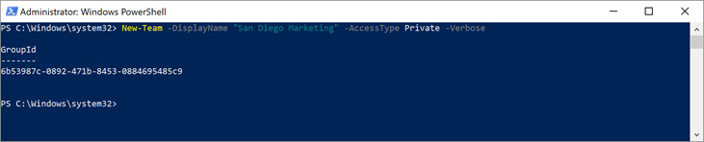

**Note:** The GroupID is important when you wish to assign classification policies to the underlying Office 365 group, in addition to when you need to remove the team among other things.

Within the Microsoft Teams client (teams.microsoft.com) we can see the team has been created:

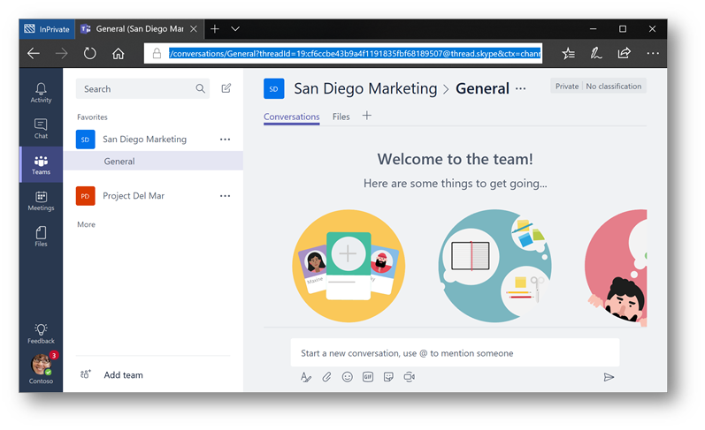

To remove the team, type the following and press **Enter.** Where <GroupID> is the GroupID of the team you created:

|  |
| --- |
| Remove-Team -GroupID <GroupID> |



**Conclusion:** These are some of the basic functions you can perform with the Microsoft Teams PowerShell Module.

* Lancer PowerShell en mode Admin

$session=New-CsOnlineSession

import-PSSession $session

Ex pour le mode Teams Oly

Grant-CsTeamsUpgradePolicy -PolicyName UpgradeToTeams -Identity [ama@ip-label.com](mailto:ama@ip-label.com)

!!!!! Il faut executer cette commande avec l’upn trigramme

Apercu client Skype au demarrage en mode Team Only

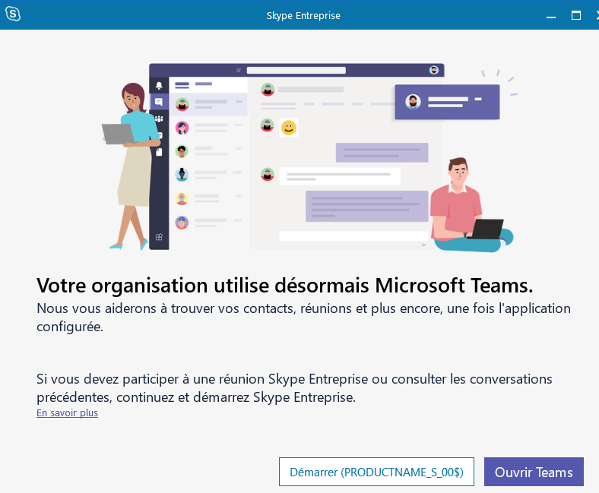

Mode Stratégie par défaut sur le Tenant

Grant-CsTeamsUpgradePolicy -PolicyName $null -Identity [ama@ip-label.com](mailto:ama@ip-label.com)

Grant-CsTeamsUpgradePolicy -PolicyName Islands -Identity , sis@ip-label.com

Grant-CsTeamsUpgradePolicy -PolicyName Islands -Identity